# ATS – Asia Ticketing Script

# Fare Loading Guide

Version No: 12.0

# Prepared by: Nikki Bromwich

# Date: 28 February 2012

Table of Contents

Purpose of the Document 3

ATS Overview 3

Agency Private Fare Contract 3

Fields within OTHER NOTES 4

PFBC 4

TFBC 4

AWL 4

AOPENSEG 4

TURNPOINT 5

FOP 5

EB2 5

FC1 5

FC2 5

FC3 6

NV 6

NR 6

RP 6

# Purpose of the Document

This document is to support the loading of APF fares with the data required by the ATS script.

# ATS Overview

ATS automates the quoting and pre-ticketing process for Agency Private Fares by allowing the Travel Agent to manipulate the fare data according to special codes loaded into the OTHER NOTES section of the APF contract & also by information inputted by the agent, through the ATS GUI itself.

# Agency Private Fare Contract

ATS will read and apply data found in the OTHER NOTES field of the APF contract.

To add this data into the APF contract you need to select “Rules Text”

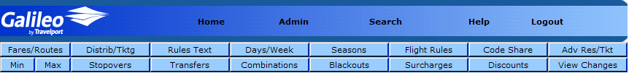

You would then use the drop down menu to select OTHER NOTES.

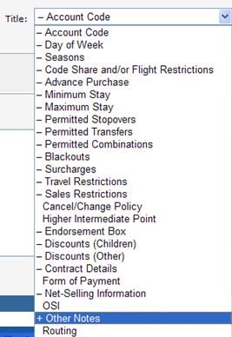

Then you would add the relevant details in the following format for ATS to Validate.

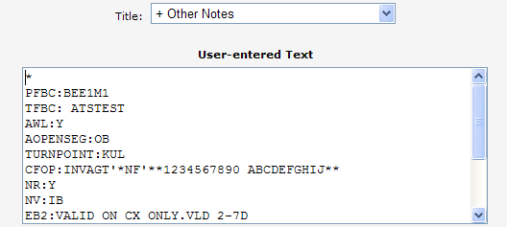

# Fields within OTHER NOTES

PFBC**: Published Fare Basis Code**

Action: Uses the Fare Amount only for the ticket

Format: Alphanumeric 08 Characters

Host entry equivalent: FQS1@YEXT. etc

This is to tell the system which fare basis is to be used when obtaining the published fare. The **fare amount only** from this field will be input on the ticket.

This published fare basis coded is NOT editable by the user.

If there are multiple Fare basis' required, each segments fare basis will be separate by a "/" delimiter in the APF Fare notes.

Ex: for the following journey

JKT SIN YEXT

SIN SYD YEE60

SYD SIN YEE60

SIN JKT YEXT

The PFBC in the APF Contract notes will show : **PFBC : YEXT/YEE60/YEE60/YEXT.**

TFBC**: Ticketing Fare Basis Code.**

Action: Replaces the “Fare Basis” in the ‘Fare calculation’ and ‘Segments’ on the ticket

Format: Alphanumeric 08 Characters

Host Equivalent: FBUFB/ or FBUFB1/+…

This is to tell the system what fare basis is to be printed on the ticket. The script will update the fare basis fields in the stored fare quote with the fare basis listed in the TFBC field.

This ticketing fare basis code is NOT editable by the user.

If there are multiple Fare basis' required, each segments fare basis will be separate by a "/" delimiter in the APF Fare notes.

Ex: for the following journey

JKT SIN Y

SIN SYD YEL35

SYD SIN YEL35

SIN JKT Y

The TFBC in the APF Contract notes will show : **TFBC : Y/YEL35/YEL35/Y.**

AWL**: Waitlist Allowed**

Action: Validates if Waitlists are permitted or not

Format: **AWL:Y**

**AWL:N**.

This indicates whether the fare will allow waitlist status.

When the script is used to fare quote a booked itinerary, it will validate whether Waitlist Segments are allowed and only quote if the itinerary meets the requirement.

This is NOT editable by the user

AOPENSEG**: Allow Open Segment**

Action: Validates if Open Segments are permitted

Format: **AOPENSEG:IB** for Inbound only

**AOPENSEG:OB** for Outbound only

**AOPENSEG: IB/OB** for Both, Enter

**AOPENSEG:N** for Open Segment not permitted

This indicates whether the fare allows Open Segment ie Inbound or Outbound or Both.

When the script is used to fare quote a booked itinerary, it will validate whether ‘open segments’ are allowed and only quote if the itinerary meets the requirement.

This is NOT editable by the user.

TURNPOINT**: Turnpoint Airport code**

Action:Validates the specific turn point for the itinerary

Format: 03 letter airport code

**TURNPOINT:JFK**

**TURNPOINT:JFK/EWR**

This indicates which airport code should be considered as the TURNPOINT. You must entry airport codes – city codes will not be validated.

This is NOT editable by the user.

FOP**: Form of Payment**

Action: Enters the form of payment that will be used

Host: TMUxF

Format: Alphanumeric 12 Characters.

**FOP: INVAGT** (example for Agent Invoice)

This is to indicate the form of payment on the ticket. Can also be added as an endorsement for Credit Card (CC) form of payment.

This is editable through the ATS script. Values entered can be S, CK, INV<free text>, NONREF<free text>, MS<free text> or <free text>

EB2**: Endorsement Box 2 (Enter second line of endorsement text)**

Action: Adds additional text into your endorsement field

Format: Alphanumeric 28 Characters.

**EB2: VALID EX:HKG ONLY ON CX**

The first line (28 characters) of the endorsement text is added in the rule conditions. The next 28 characters of the endorsement text is added here. Limited to a total of 56 characters as Endorsement text.

This is NOT editable by the user.

FC1**: Endorsement Text (Enter the additional endorsement text)**

Action: Adds additional text into the fare calculation line on the ticket

Format: Alphanumeric 45 Characters.

**FC1: VALID EX:TPE ONLY ON CI** (Example)

When the Endorsement text does not fit in the EB2 box above, the additional text (i.e. excess of 52 characters) is added to this field and displayed in the empty space of the Fare Calculation area of the ticket.

This is NOT editable by the user.

FC2**: Endorsement Text (Enter the additional endorsement text)**

Action: Adds additional text into the fare calculation line on the ticket

Format: Alphanumeric 45 Characters.

**FC2: VALID EX:SIN ONLY ON SQ** (Example)

When the Endorsement text does not fit in the FC1 box above, the additional text is added to this field and displayed in the empty space, of the Fare Calculation area of the ticket.

This is NOT editable by the user.

FC3**: Endorsement Text (Enter the additional endorsement text.)**

Action: Adds additional text into the fare calculation line on the ticket

Format: Alphanumeric 45 Characters.

**FC3: VALID EX:SYD ONLY ON QF**

When the Endorsement text does not fit in the FC2 box above, the additional text is added to this field and displayed in the empty space, of the Fare Calculation area of the ticket.

This is NOT editable by the user.

NV**: Not Valid After/Before**

Action: Adds the NVA/NVB dates to the ticket

Format: **NV:IB** for Inbound only

**NV:OB** for Outbound only

**NV:IB/OB** for Both

This is used to indicate, on what portion of the journey do the NVA/NVB dates entered, need to be applied. Do not enter this field if Not Valid Before/ after dates do not apply.

This is NOT editable by the user.

NR**: Net Remit**

Action: Validates if credit card FOP is permitted on the fare

Format: **NR:Y**

**NR:N.**

This is to indicate whether or not the specific contract allows/prohibits a credit card FOP on the ticket. Only used if there is an exception to the carrier Rule.

RP**: Reduce Price**

Action: Reduces the published fare by a percentage

Format: Enter 02 Digit Numeric.

**RP:10** (example to reduce published fare by 10 percent).

This is used to allow the user to calculate base fare using a percentage reduction to published fare.

TC: **Tour Code**

CTC: **Combination Tour Code**

CFOP: **Combination Form of Payment**

NET**: AUD800.00**

Logic Used

PFBC is always used for the fare value to apply on the ticket.

TFBC (when found) is used for the fare basis and fare calculation line

If there is no TFBC data, then ATS will use the fare basis from the net fare quote.

Please note ATS will change the quote to a fare build (*FB1) and then build the quote from details found in the OTHER NOTES field of the fare contract.

**Other Notes Template with most commonly used fields is displayed below:**

**\***

**PFBC:**{Pricing Fare Basis Code}

**TFBC:**{Ticket Fare Basis Code}

**AOPENSEG:**{IB/OB} or {IB} or {OB}

**AWL:**{Y/N}

**FOP:**{Form of Payment}

**NR:**{Y/N}

**EB2:**{Endorsement#2}

**FC1:**{Endorsement#3 or Fare Calculation#1}

**FC2:**{Endorsement#4 or Fare Calculation#2}

**FC3:**{Endorsement#5 or Fare Calculation#3}

Please ensure that the “**\***” is put on the first line of the Other Notes Box.

Please see Examples of the Other Notes Text with ATS Script information included.

**Example 01**

**\***

**PFBC:**MEE1ME

**AOPENSEG:**IB

**AWL:**N

**FOP:**QS.CNED

**NR:**N

**TC:**SING01

**EB2:**VLD SQ OPTD FLTS ONLY

**FC1:**HKGSIN SQ857/859*SINHKG SQ862/866*

**FC2:**OB NO 23-27DEC5 25JAN-2FEB6 N AFT 31MAR6*

**FC3:**TKT VLDTY 2-14D AND COMPLETED B4 30JUN6

**Example 02**

**\***

**PFBC**:Y

**TFBC**:YEE14

**AOPENSEG:**IB/OB

**FOP:**INVAGT

**NR:**Y

**EB2:**NONENDO.RERTE

**FC1:**VALID ON CX ONLY (45 characters)

**FC2:**SQ857/859 (45 characters)

**FC3:**MIN STAY 2 DAYS MAX STAY 5 DAYS (45 characters).